

OBJECT ORIENTED PROGRAMMING (CSE -2143) MINI PROJECT REPORT ON

Modern Calculator

SUBMITTED TO
Department of Computer Science & Engineering

By

Sr. No | Name | Registration Number | Roll Number | Section
1. | Ripudaman Panwar | 220905350 | 43 | D
2. | Saivya Singh | 220905370 | 44 | D
3. | Prathit Kapil | 220905378 | 45 | D
4. | Rishit Mandal | 220905390 | 45 | D

Name & Signature of Evaluator 1 Name & Signature of Evaluator 2

(July 2023 – Nov 2023)

Table of Contents
 |  |  |  | Page No
Chapter 1 |  |  | INTRODUCTION | 1
 | 1.1 | Introduction |  | 2
 | 1.2 | Project overview
Chapter 2 |  |  | FEATURES
Chapter 3 |  |  | WORKING
 | 3.1 | Concepts
Chapter 4 |  |  | RESULTS
 | 4.1 | Expected output
Chapter 5 |  |  | CONCLUSIONS AND FUTURE ENHANCEMENTS
 | 5.1 | Conclusion
 | 5.2 | Future Enhancements

- INTRODUCTION

  - General

This report documents the development and features of a mini project that involves creating a calculator using the Java programming language. The project aims to provide a basic calculator application with essential arithmetic operations.

  - Project Overview

The Java-based calculator project is designed to offer users a simple yet functional calculator with a visually appealing interface. The primary focus is on implementing basic arithmetic operations, including addition, subtraction, multiplication, and division. The project's main components include the GUI, input/output functions, and the core calculation logic.

- FEATURES

a. Graphical User Interface (GUI): The calculator features a user-friendly GUI that includes buttons for numbers, arithmetic operations, and a display screen to show input and results. The GUI is created using Java Swing components to provide a pleasant and intuitive user experience.

b. Arithmetic Operations: The calculator supports standard arithmetic operations, allowing users to perform addition, subtraction, multiplication, and division. It handles decimal numbers and provides an equals button to execute the calculation.

c. In this calculator, user-friendly buttons are the primary means of input. With a dedicated button for each digit, from 0 to 9, and separate buttons for common arithmetic operators like addition, subtraction, multiplication, and division, users can effortlessly input their calculations. The use of buttons not only simplifies the input process but also minimizes the chances of errors, ensuring a smooth and efficient calculation experience.

3.WORKING

3.1 Concepts
Our calculator application effectively employs several key concepts of object-oriented programming (OOP) to provide a robust and user-friendly experience.
The code is well structured and includes various classes for mathematical operations, memory management, and user interface components. Object-oriented principles such as encapsulation are used to protect sensitive data, inheritance allows different computing modes and polymorphism allows processing of different mathematical functions. Exception handling allows you to smoothly manage unexpected scenarios.

4.RESULTS

4.1 Expected Output

The expected output of our calculator created using Java is the accurate result of
arithmetic operations performed by the user. When a user inputs numbers and
operators through the graphical user interface and presses the "equals" button, the
calculator should display the precise calculation result. This result should reflect the
outcome of the selected arithmetic operation, whether it's addition, subtraction,
multiplication, or division. Overall, the expected output of the Java calculator is
reliable, error-free, and promptly delivered mathematical solutions, enhancing the
user's ability to perform calculations with confidence.

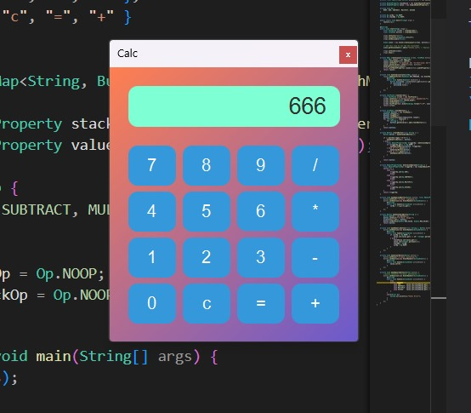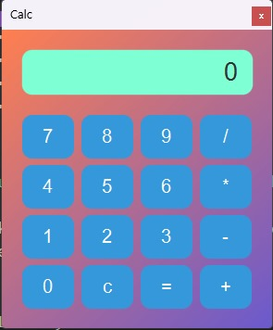
5.CONCLUSION AND FUTURE ENHANCEMRNTS

5.1 Conclusion

The Java-based calculator project serves as an example of a simple yet functional
application developed using Java. It provides a valuable learning
experience for those interested in GUI development, event handling, and basic
arithmetic calculations. The calculator's clear interface, input validation, and memory
functions make it a practical tool for everyday use and a foundation for more
complex calculator applications.

5.2 Future Enhancements

Future enhancements for the project may include the addition of scientific functions,
a history feature to store previous calculations, and support for more advanced
mathematical operations. These enhancements can extend the project's capabilities
and utility.

